**Groupanizer Manual**

My Groupanizer Information:

Groupanizer website URL: <http://soundofillinois.groupanizer.com/dashboard>

My Username: _______________

My Password: _______________

**How to Log in**:

(If you have never logged in, please see first time log in instructions below)

1: Go to the URL: (<http://soundofillinois.groupanizer.com/dashboard>)

2 Enter your username and password (If you do not have a username or password, see first time login instructions below:)

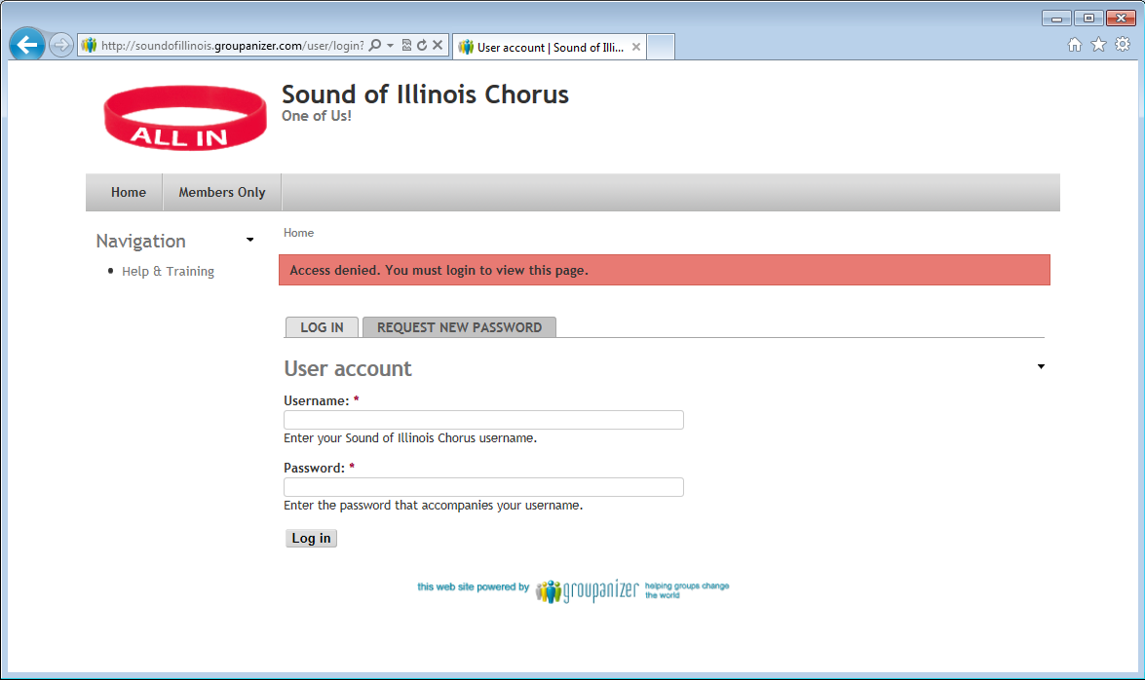

At this point you should be at the main Groupanizer screen.

Note: If you see the “About Us” page, you can click the “Members Only” Link to get to the log in screen.

**Groupanizer Main Screen**

The following image shows some important features of Groupanizer. Descriptions will follow below.

Menu Bar

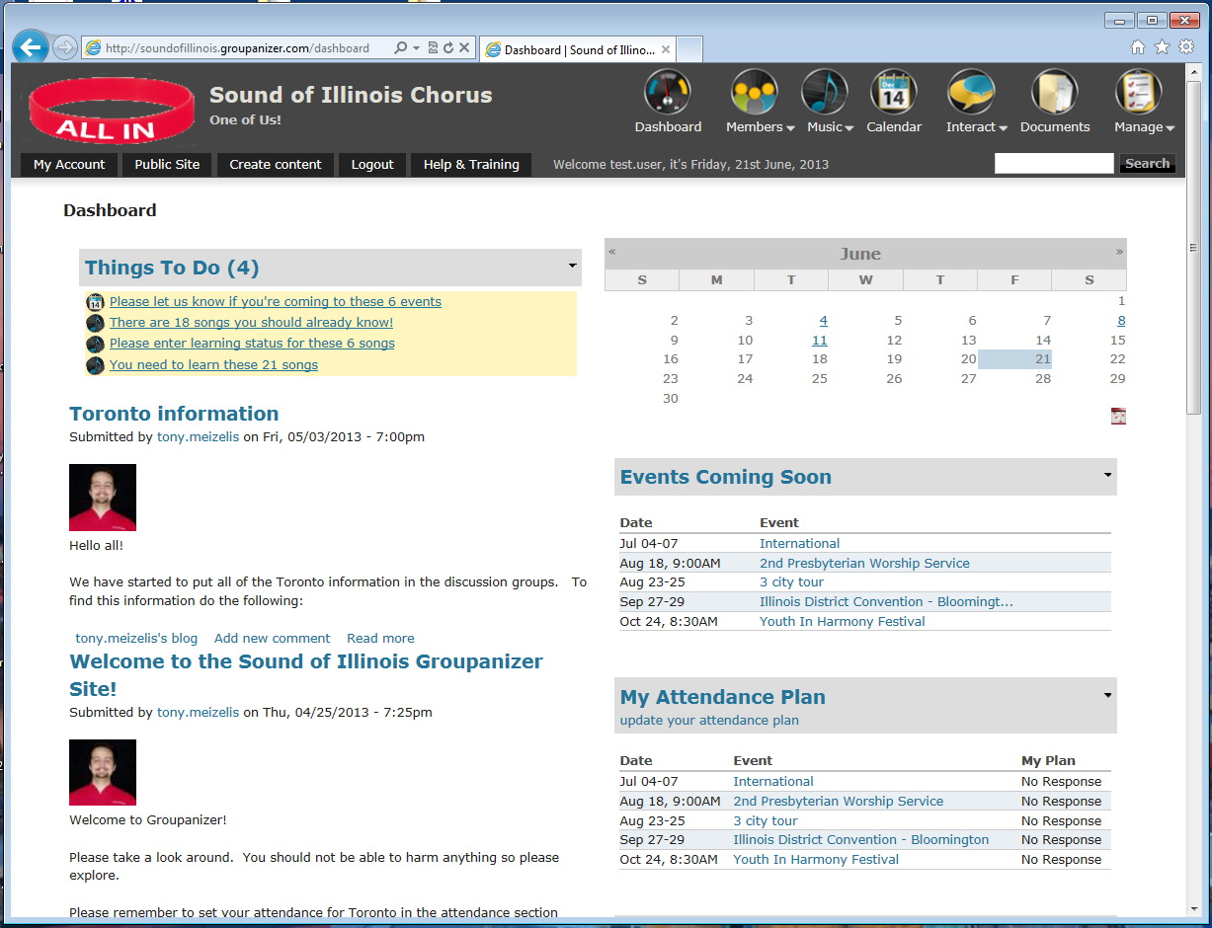

Other info

My Account

Calendar

News

“To Do List”

**Menu Bar**

This is the main way to navigate Groupanizer. See below for more information about the important items

**My Account**

This link shows you your information within Groupanizer. You can also edit the information that’s there.

**To Do List**

The to-do list is a short list of things needing attention. .

**News**

If there are any major news items that have been posted to Groupanizer, they will be shown here.

**Calendar**

Shows a basic calendar. If there is an event scheduled for that day, the day will change color and be underlined. Click on the day to go to that event.

**Other info**

There is a list of other information available, such as upcoming events, your attendance, and songs to be learned.

.

**Menu Bar Navigation**

**Dashboard** – Click on the dashboard icon any time to go back to the main screen.

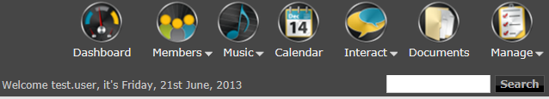

**Members**- information about members.

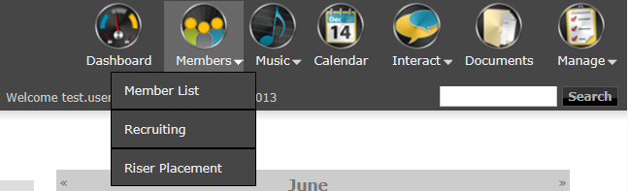

*Member List*- Contains a list of members of the chorus

*Riser Placement* – shows riser placements for various events

**Music** – for information about music

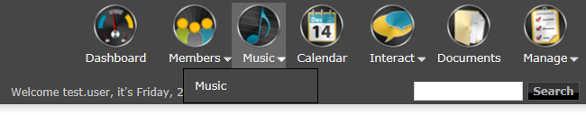

*Music* – shows a list of music currently available on Groupanizer.

**Calendar** – shows a calendar with the currently scheduled Chorus Events



**Interact**- Things for chorus members to be able to interact with Groupanizer.

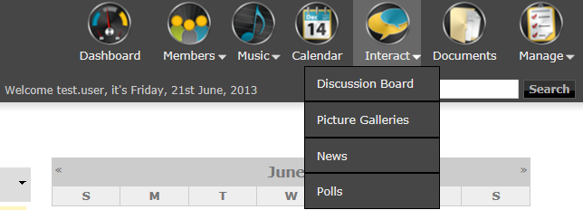

*Discussion Board* – Has various discussions. Currently as of the writing of this manual there is choreography information there.

**My Account**

When you click My Account, you can access information related to you within Groupanizer.

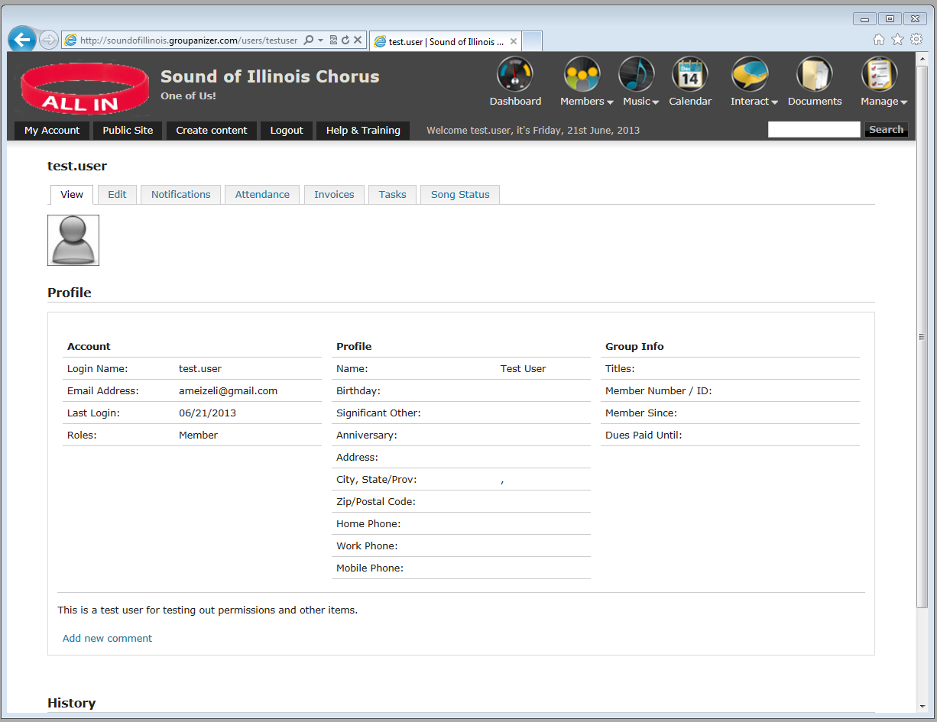

Edit

Attendance

Song Status

Edit – Allows you to edit your account information. (Password, profile information, email addresses)

Attendance – This link allows you to indicate which chorus events you are attending.

Song Status – Shows a list of songs and allows you to indicate which songs you have learned, are learning, or haven’t started.

**First Time Login Instructions**

The original invitation to Groupanizer was sent out via email. You should have received an email from Groupanizer inviting you to change your password. That email should also contain your username. If you did not receive this email, please ask Tony to resend this email.

Once you have the Groupanizer invitation email, you can click on the link. It will bring you to a page for you to enter in your password. It will give you some feedback on how secure your password is. It is recommended to have at least three of the four types of characters in your password: Numbers, capital letters, lower case letters, Symbols.

After you have changed your password you may go to <http://soundofillinois.groupanizer.com/dashboard> and log in as above.

**Frequently Asked Questions**

* I don’t have a username or password.
  + Please see the “First Time Log In” section above.
* I have forgotten my password!
  + Go to <http://soundofillinois.groupanizer.com/dashboard> and click on the ‘Request New Password’ link. Groupanizer will send password change instructions via email.
* How do I find the choreography videos?
  + Hover over the ‘interact’ button and select the Discussion Groups link.
  + Click on the ‘choreography’ link on the left side
  + There is a link for the choreography for each set.
* How do I find the music on Groupanizer? How do I download Music from Groupanizer?
  + Click on the music button. You will see a list of songs.
  + Click on a song name to look at the information for that song.
  + Sheet music and learning tracks (if they exist) are shown in the attachment section.
  + To download, right click on the song name and click “Save As….”
* How do I get the music into my music software/iPod/etc.?
  + There are many different kinds of music software, but in general the process will be as follows:
  + Download the learning tracks from Groupanizer (see above). Make sure you remember where you saved it.
  + Open the music software you want to use
  + Go to the file menu, open.
  + You might also be able to drag the songs onto the music software.
* How do I find out where I am supposed to stand on the risers?
  + Hover over Members menu bar icon
  + Click ‘riser placement’
  + Click on the link for the riser placement you are interested in.
* How do I update what songs I have learned?
  + Click on ‘My Account’
  + Click on the song status tab
  + You can change your status for all songs using the drop down
  + If you have comments about your status, you may click on the ‘none’ text and it will allow you to enter information
* How do I update which chorus events I will be going to?
  + Click on ‘My Account’
  + Click on the ‘attendance’ tab
  + Select “no response, will attend, won’t attend” under the ‘plan’ column.
  + You may enter notes about your attendance by clicking on the ‘none’ text on the right.
* How do I update my profile/password/email?
  + Click on ‘My Account’
  + Click on the ‘Edit’ tab
  + At that page you can change your password, upload a picture (used in riser placements) on the ‘account’ page.
  + Click the ‘profile’ link to change your other profile information.
  + To change your E-mail address, click on the ‘E-mail addresses’ link. If you add a new email address, Groupanizer will send you an email to confirm that the email is valid.

Questions? Contact Tony:

Tony Meizelis

[Ameizeli+groupanizer@gmail.com](mailto:Ameizeli+groupanizer@gmail.com)